GOING THE EXTRA MILE: WHY ROGER FEDERER IS YOUR QUINTESSENTIAL ROLE MODEL

-By Dharvi Verma, BVCOE

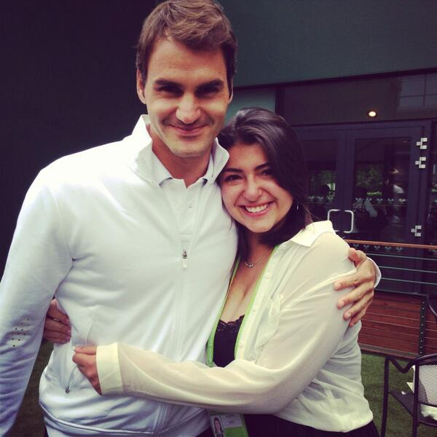

This isn’t an article meant for waxing lyrical about Roger Federer’s achievements as a tennis superstar. This isn’t about the accolades and awards he wins on a daily basis. This piece is about an athlete rising above the materialism, cheats and scandals that have marred the sporting community, and giving back to his fans. I just want to tell a story which I read on the web and which touched my heart, and took my admiration for Federer to greater heights.

This is the story of Beatriz Tinoco, a 17-year-old teenager hailing from Maryland who had survived a battle with cancer in 2011/2012. She made a simple wish to the Make-A-Wish Foundation in 2012 -meeting Roger Federer. In June 2013, she was told that ESPN was doing a piece on her high school tennis team and that is when she was told that she’ll be meeting her idol. The way she was informed is no less than a fairytale in itself. A video of Roger greeting her with, "Hi Beatriz, I heard you're a big fan of mine, so I'm inviting you with your family to come watch me play at Wimbledon. Go pack your bags, have a safe trip, and I'll see you there” freaked her out in her own words.

She flew to London the very same week and met Roger for the first time in the players’ lounge. He greeted her with a hug and talked to her for some 15 minutes. The meeting was supposed to end there but Federer, being a mensch if there ever was one, invited her to watch his practice with fellow player, Lleyton Hewitt. She was even introduced to Federer’s entourage- his coach Paul Annacone, Swiss Davis Cup captain Severin Luthi and others. She even got a chance to hit with Roger on the court. She was scared because she felt that she was good but nothing out of the ordinary. But she overcame all her anxiety when Roger’s coach, Paul, told her not to be scared of Roger at the net “because it was all pressure, he wasn't even that good”. Just when she thought that Roger had already gone beyond the call of duty and done enough, he told her that he was going to see her two days later for a tour of the Wimbledon grounds. She was shown around the all the SW19 courts the following Sunday, including the Centre Court which is often called the ‘holy ground of tennis’, by Roger and the Chairman of Wimbledon himself. If all this hadn’t surpassed her expectations already, he invited her to his press conference and even kept it on hold until she arrived. After being done with all the interviews (he does press in 3 languages, just so you know), he met Beatriz and her family in the players’ lounge and signed autographs and other tennis related stuff for them, personally addressing each one of them. To describe the end of the meeting, I’d quote her exact words, for she has written beautifully how she felt:

“He stayed a lot more than he had to for sure. But then the people from ESPN tried kind of finishing things up so that he could leave before his manager freaked out. So he went around the table hugging my mom, my dad and my sister, and then it was my turn. He told me I had been through a lot and hugged me really hard and I just started crying so much in his shoulder (it was around that time that the picture from my avi was taken haha) He was like "awnn". Then when I let go of him I was still like sobbing and I turned to him and he was kind of tearing up :') I thanked him and then he went.”

So there you have it: Roger Federer, the people’s champion.

